(Approx. 595 words)

Saved by Macrium Reflect
How I recovered from a Driver Disaster
By Tom Burt, Vice President
Sun City Summerlin Computer Club
https://www.scscc.club
tomburt89134 (at) cox.net

Introduction

For several years, I have used the free Macrium Reflect backup software program
(https://www.macrium.com/reflectfree)to back up my PC’s hard drives. My PC has a 500
GB solid-state drive (C:) and a 1 TB hard drive (E:). C: is for the Windows operating
system, user profile folders, installed applications, temp storage, and a few other file
types that benefit from the high performance of the SSD. E: is for storing all the data
files that various programs use and for cross-network backup of various shared folders
on my wife’s PC. Here’s a shot of Macrium Reflect’s main screen:
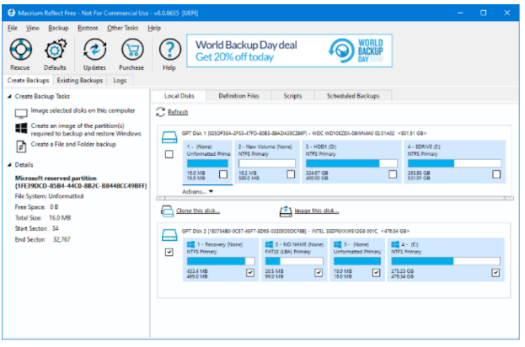

My routine has been to make a monthly image backup of my C: and E: drives to an
external 2 TB hard drive. I keep three iterations of these backups. I have also been
using Windows File History to back up folders on both C: and E: with files that change
frequently, such as my Outlook mail folders, Computer Club files, and Financials. The
File History backups go to a 64GB flash drive plugged into the back of my PC.

As part of the Macrium Reflect image backup process, I have Macrium validate the
backup, ensuring the image is readable and not corrupt. Until recently, I never had
the occasion to attempt to restore a backup image.

AMD Radeon Video Driver Update – A Fatal Improvement

In early March, about ten days after my most recent backup, Windows Update was
offering me an updated driver for the AMD Radeon graphics processor bundled with my
PC’s AMD Ryzen 2400G CPU. I deferred installing it for a few days and then
decided to check the AMD support website to see if they had a newer driver. They did,
so I downloaded that driver and ran the setup. Everything seemed to go fine; at the end
of the setup, I rebooted Windows 10, and the system looked normal.

As I was resuming work, I decided to try opening a .mp4 video file since I’d had trouble
in the past with driver updates causing video playback to fail. When I double-clicked the
.mp4 file in File Explorer, nothing happened! No program launched, and no error
message was displayed. I tried several other .mp4 files and then some .jpg and .png files with the same result. Not good!

System Restore Failed

So, I considered a bit and decided to do a System Restore, reverting to the
system state before installing the driver. The driver setup had created a restore point,
so I expected to be back to the initial state of the system in relatively short order. The
System Restore kicked off but ran very slowly. After about 45 minutes, it switched to
displaying a “Restarting System” message with a spinning cursor. That stayed on the
screen for half an hour, with no sign of any system activity. Really Not good!
I pressed and held the power button to reboot the PC. It started to boot but then
hung with a spinning cursor. Really, really not good!

Restore From the Last Macrium Reflect Image

I decided to try restoring my C: drive from the most recent Macrium Reflect backup
image, which was only about 10 days old. I first went to my wife’s PC and used her
Macrium Reflect to create a bootable Macrium Repair DVD, just to ensure I had the
latest version of the Repair tool.

On my PC, I rebooted and pressed F12 Boot menu to allow me to boot from the DVD.
Macrium’s Repair Disk boots into a minimal version of Windows (Win RE) and then
launches the Repair Tool. I pointed it at the most recent image of my C: drive on my
external 2 TB hard drive and then selected my PC’s C: drive for the target. Finally, I
clicked on the Restore button. The Repair tool went to work restoring all of the C: drive’s
partitions, including the UEFI partition. The entire restore ran for about 45 minutes. When it
was finished, I clicked to exit the Repair Tool, and my PC restarted. When the restart

was finished, my Windows 10 PC was fully functional, and my data files on the C: drive
were reverted to the date of the image backup – i.e., about 10 days old.
Recovering Changes After the Last Image Backup

Happily, because almost all my application data is kept on my E: drive, it was unaffected
by restoring my C: drive. The MS Outlook data files for my various email accounts
and archives, my tax data files, and a few other files in the Documents folder were all
that were out of date.

I had hoped to restore those from my File History backup USB flash drive. But, to my
dismay, unnoticed by me, that backup drive had failed and become unreadable.
I used the File Explorer to check dates on files in my profile folder and satisfied myself
that the restored Macrium Reflect image had brought back the most recent copies of
everything but the various Outlook data files. Fortunately, my email providers (Cox.net
and Gmail.com) retain copies of emails on their servers for 30 days. So, I launched MS
Outlook and it downloaded everything new since my last image backup. In all, I had
about 500 emails that I had to review and reprocess (file or delete). After about an hour,
I had everything back close to what it had been before the installation of the buggy driver.

I ran Windows Update, and it installed any updates subsequent to the date of the image
backup. I had to reinstall some updates to the H&amp;R Block software and a software
update to my video editing program. By the end of the day, everything was back in good
order.

Conclusions and Takeaways
The old saw “If it ain’t broke, don’t fix it!” seems still to be good advice. However, the flip
side is we’re now at constant risk of attacks from malware, and we’re endlessly told by
security pundits to keep our system software up to date. So generally, one must trust
the software vendors and install updates when offered.

This experience demonstrates why it’s so important to make regular image backups of
your running system, as well as your data. Had I not had a recent Macrium Reflect
backup, it would have taken me several days to rebuild my system, and I would have
lost much more data.

I was fortunate that the failure of my File History backup drive in my hour of need didn’t
matter. But things could have been much worse.

I was also fortunate in my choice of system configuration to have separated my main
data drive from my operating system drive. That greatly lessened the impact of restoring
my system drive from a backup image.

As a result of this experience, I’ve made a few adjustments to my backup routine. I now
make an image of the C: drive weekly so that it will be less out of date if I have to do a
restore. I’m continuing to back up my E: drive monthly. I also decided to take more
advantage of the 1 TB of cloud storage that comes with my Microsoft 365 subscription. I
wrote a short command script to copy all my Outlook and tax files to the OneDrive sync
folder, from which they get backed up to my OneDrive cloud storage. Currently, I run that
command file daily. I will likely add other file folders from my E: drive to that set.
I also plan to buy a few new reliable flash drives and go back to using Windows File
History.

